Two Weddings and a Funeral
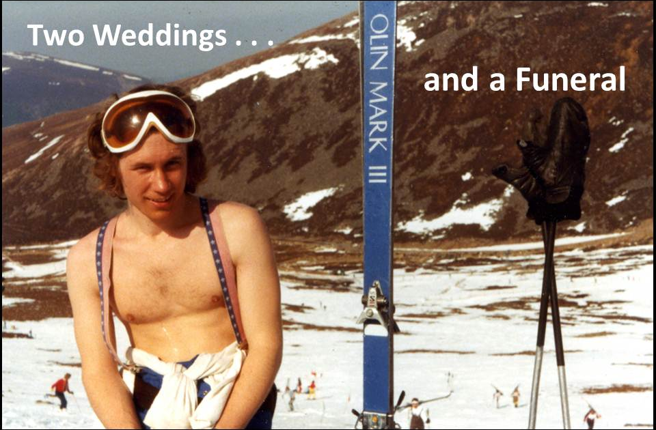 | Imagine that it’s 1977, and you are a young PhD student, arriving in the Cairngorms as captain of Surrey, one of the worst ski teams in the country. There on the slopes you meet the captain of City, the other worst ski team in the country. He is brown, fair-haired and beautiful, with a snub nose, twinkly eyes and an impish grin. That is how Tom and I first met, and fell in love.
Back down south we began meeting, and very soon I became one of the subjects for his PhD research into colour vision. This involved sitting for hours at a time in a dark, airless room, shouting out my perceptions of coloured squares. One hot day I had the temerity to ask for a can of coke. He got me one but this request sent him into panic because he calculated that if each of his subjects asked for coke for each session he would be broke and unable even to feed himself. Happily I was content with water for the rest of the sessions.

This was not my only adventure as one of his subjects. Many years later, when we all lived in Tubingen for a year, he fixed a gold-leaf electrode onto my eye the wrong way round and, as I watched the displays and pressed the buttons, it gradually scraped off my cornea. Happily, as we were then in the Tubingen Eye Hospital, a doctor was quickly found, my eyes were bandaged up and I had the interesting experience of being blind for three days. Also happily, corneas mend very fast!

In early July that year Tom and I got privately ‘married’ on an acid trip in the woods near Guildford. (see my brief account ). | 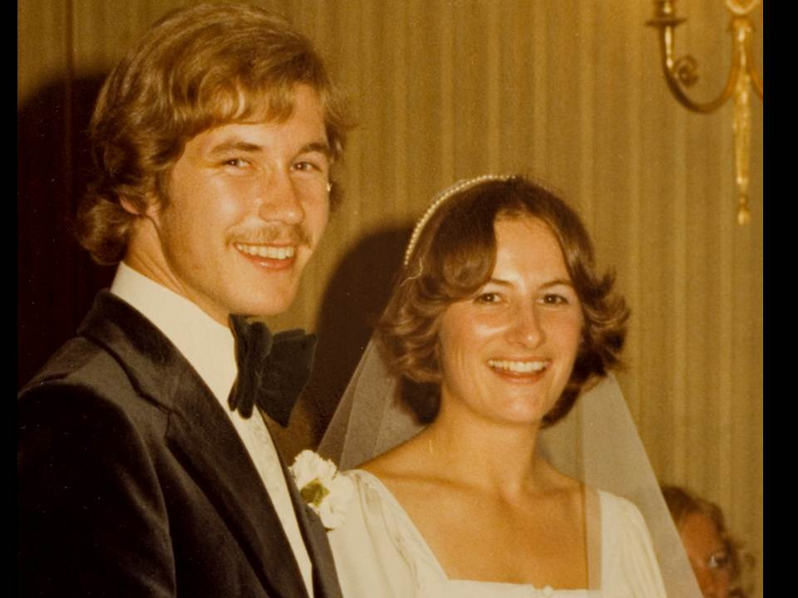  Then we wanted to get on with the real thing and, much to my parents’ distress, we insisted on getting married that September – just 5 months after we’d first met. All our parents were there, as you can see.
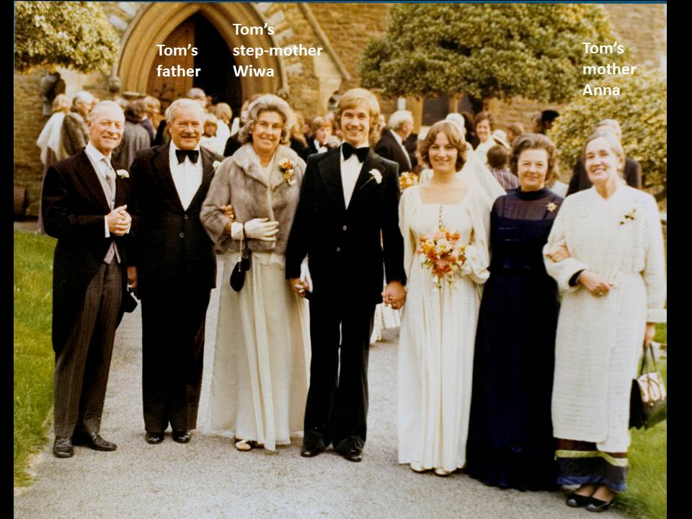

A year after that we moved to our lovely Pear Tree Cottage, south of Bristol, and there Emily (born 1982) and Joly (1984) grew up. Tom worked at Bristol University and I managed to write and do a little research at home.
Life with Tom was not always easy – and I don’t expect life with me was always easy either. But it was certainly never dull! In 1990 he left and we managed to sort out a life that worked, sharing the kids between us. After a few years we became good friends again and by the time he died we were all very close and he was very much the heart and soul of our peculiar extended family.
We did not get divorced until 2009, and here you can see us, the night before the event, celebrating in typical Tom style. I believe we shared two bottles of champagne and 7 spliffs that evening – reminiscing about our long and eventful marriage. I seem to remember Tom telling me about all the times he had nearly killed the children – but they are both still alive and well. | 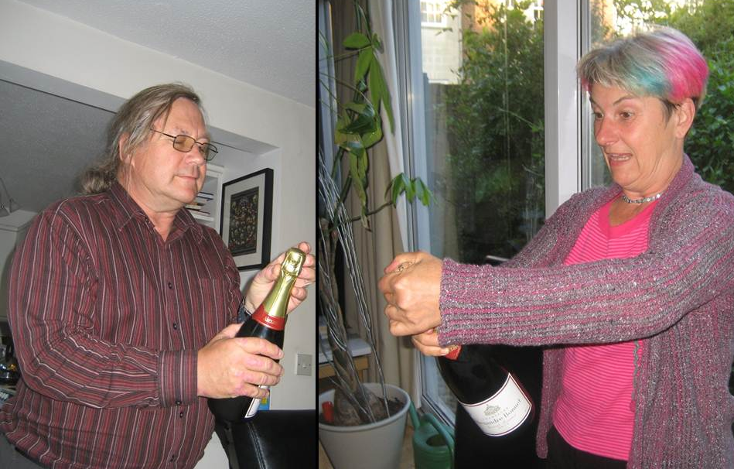
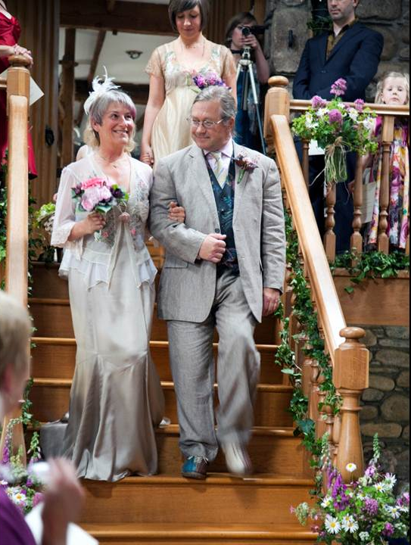 | In 2010 Adam and I got married and I was thrilled that Tom wanted to give me away. If you have to be a bundle to be given from one man to another, what could be better than Tom giving me to Adam on our own bridge down in Devon? He even gave Adam the ring with which he and I had been married all those years before. I am so glad that he was here for this very special event.  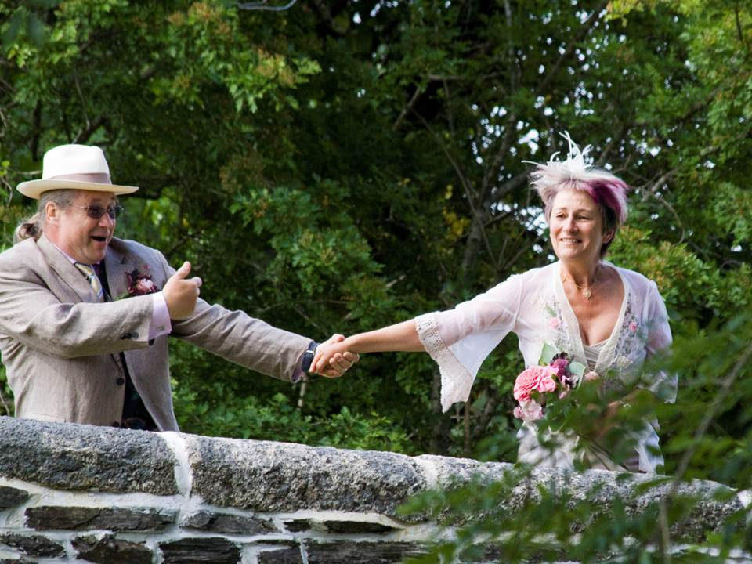

Every year Tom was the Christmas cook, making truly brilliant Christmas dinners for all the family. We will miss this, and him, as long as we live.

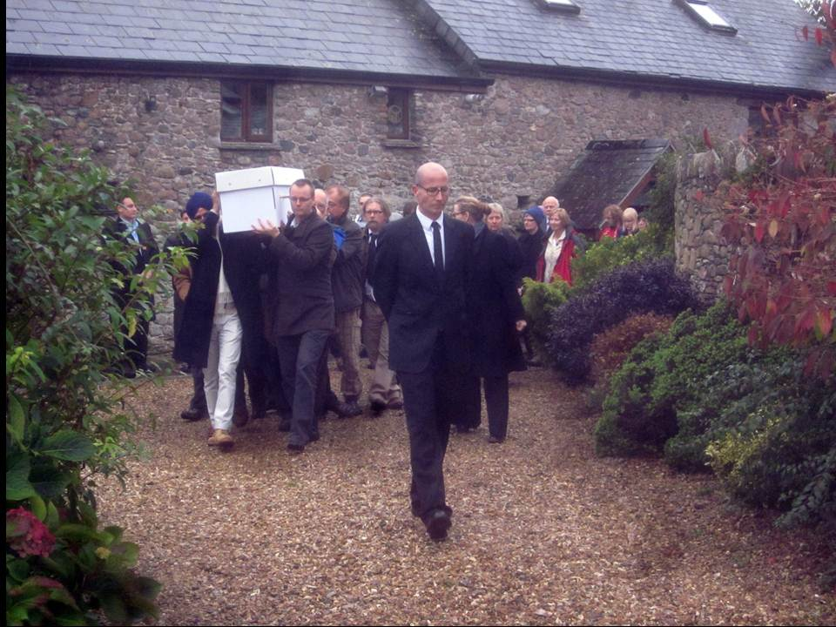

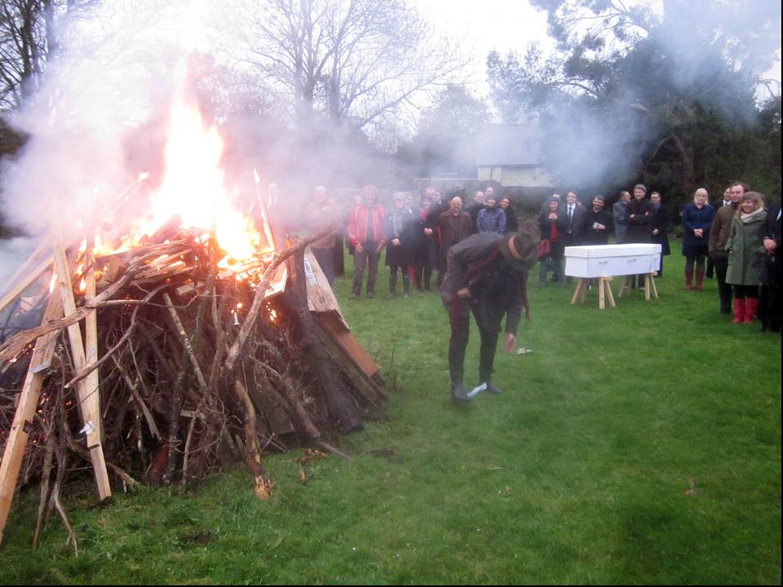 | 